PSTU Head Says Public Sector Needs Radical Transformation
Monday, 21 November 2011 11:09
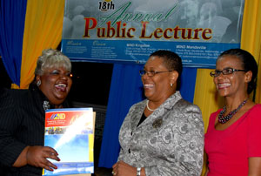
Chief Executive Officer (CEO) of the Public Sector Transformation Unit (PSTU), Patricia Sinclair-McCalla (centre), being greeted by Director, Business Development and Communication at the Management Institute for National Development (MIND), Glynis Salmon. and MIND’s Chief Executive Officer (CEO), Ruby Brown, following the institute’s 18th Annual Public Lecture at its Kingston campus on Thursday (November 17).
KINGSTON — Chief Executive Officer (CEO) of the Public Sector Transformation Unit (PSTU), Patricia Sinclair-McCalla, says that if Jamaica is to achieve sustainable growth and development, the public sector has to be radically transformed.
"Jamaica needs a transformed, cohesive sector that is performance based, efficient, cost effective and service oriented,” she told the Management Institute for National Development’s 18th Annual Public Lecture on Thursday (November 17). She was speaking on the theme, "Transforming the Quality of Leadership in the Jamaica Public Service – Can We Cross it?"
Mrs. Sinclair-McCalla said that change must also come in terms of leadership in the public service, arguing that the sector needs more bold and decisive leaders.
"What we need are transformational leaders, who are able to articulate their vision with clarity, so that others are able to identify with that vision and develop the passion to work collectively to actualize that vision,” she argued.
She noted, however, that in addressing leadership in the public service there has to be an understanding of the cosmology of the public sector, which comprises 16 ministries, approximately 230 entities, inclusive of statutory bodies, limited liability companies and other public bodies, in addition to executive agencies that are departments of government.
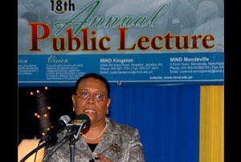
Chief Executive Officer (CEO) of the Public Sector Transformation Unit (PSTU), Patricia Sinclair-McCalla, speaking at the Management Institute for National Development’s (MIND) 18th Annual Public Lecture on Thursday (November 17) on the institution’s Kingston campus.
She pointed out that the public sector comprises in excess of 120,000 public officers, excluding 4,500 Jamaica Defence Force (JDF) personnel, and is, in fact, the largest employer, contracting just over 10 per cent of the Jamaican labour force.
She argued that, against this background, the public sector must have a new mindset, along with requisite skills and competencies, to be responsive to the national and global landscape.
"Jamaica has continued to languish in its quest for a highly competent, world class public sector, capable of providing the effective governance necessary to advance the country," she stated.
She said there is a need to improve performance and increase productivity, for the country to achieve sustainable growth and development, and the efficacy of the public sector will determine how Jamaica progresses, as a nation, towards realising that objective.
"A major component of quality leadership in the public service is prudent management of all resources, to include financial, human and material. We want a public sector that is competent in financial management, as we must know what the true cost to execute the business of government is, and we must spend only what we can afford to," she remarked.

Chief Executive Officer (CEO) Of the Management Institute for National Development (MIND), Ruby Brown (left), presents Chief Executive Officer (CEO) of the Public Sector Transformation Unit (PSTU), Patricia Sinclair-McCalla, with a plague, following MIND’s 18th Annual Public Lecture on Thursday (November 17) on the institution's Kingston campus.
She said there is a need to institute a financial management system that will facilitate accurate data in the publication of annual reports, not just estimates of expenditure.
She said there was also need for a paradigm shift, in terms of the leadership roles of women in the public sector.
"We must address our cultural issues to include the gender biases that permeate our society… as we need to bring women into the decision making domain,” she argued.
The MIND Annual Public Lecture serves as a vehicle to stimulate public awareness on issues of national, regional and global importance, and to provide a forum of exchange of information that result in improved quality of thought and response. Speakers, over the years, have included Director General, Planning Institute of Jamaica (PIOJ), Dr. Gladstone Hutchinson, and former Research Fellow at the Mona School of Business, Professor Barry Chevannes.
MIND is an Executive Agency of the Government, and an accredited tertiary level training institution.

By Athaliah Reynolds, JIS Reporter

